Orienteering Club in Calgary

Summary
Based on the insightful slideshow presentation and the details shared by Vital, we could understand that the Foothills Wanderers Orienteering Club is seeking help in selecting a location for their next Orienteering Events. Our objective is to identify which location is conveniently accessible to students from various universities and colleges. The aim is to facilitate these students' participation and engagement in outdoor activities, which is a new venture for many.

Moreover, the club has emphasized the necessity of a general demographic data analysis to scrutinize the evolution of their event participants over the years. This analysis will enable them to identify trends and potentially focus on demographic groups that may have seen reduced representation recently.

From these requirements, it is evident that the primary beneficiary of our data analysis will be the management of the Orienteering Club. They require actionable insights to make informed decisions regarding future events and promotional strategies.

To encapsulate the club's needs, I would suggest delineate the following goals for our project:

1. Perform a data analysis that cross-references chosen event locations with the geographical distribution of student campuses to determine which locations are most accessible.

2. Develop a tool designed to analyze the accessibility of potential locations for new orienteering events.

3. Execute a comprehensive demographic analysis of the participants in the Orienteering Club's activities.

4. As an additional deliverable, produce a color-coded visualization map of Calgary City highlighting areas based on their accessibility in relation to future events.

5. Furthermore, we should explore the possibility of integrating tools on the Foothills Wanderers Orienteering Club’s website. These tools would assist students in identifying the most accessible locations for upcoming events, enhancing their user experience and participation rates.

6. Deliver roadmap for future developments

7. Do more research on Calgary transit

Work sheet

Project team roles
- Gurmol Sohi - administrator from Data for Good
- Hanna - observer
- Sailaja - observer
- Reimark - data analysis and visualization
- Nero - ?
- Natalia - business analysis, g-sheet formulas, data product v1.0
- Vanessa - data analysis
- Vital - requirements gathering, user stories, architecture,
- Zoe - maps visualization, development on google map and web-app, data product v1.1

Tasks
to achieve goal number 1 (Perform a data analysis that cross-references chosen event locations with the geographical distribution of student campuses to determine which locations are most accessible.):
- Add all the events coordinates to the spreadsheet dataset Sheet 2- Natalia
- Add all the universities addresses to the spreadsheet dataset Sheet 2 column C - Vanessa ( added 4 campuses as a sample - Natalia)
- Create accessibility/time to travel results dataset for one event location to all campuses locations in the spreadsheet using formula - Natalia
- Create accessibility/time to travel results datasets for the rest of the universities - Vanessa
- Experiment with visualization of the datasets using standard Sheets graphs - Natalia, Vanessa, Reimark
- Experiment with visualization on google map using web-page and programming - Zoe
- Create presentation slides for the showcase
- Present the slides

Tech approach Option 1:
https://lucid.app/publicSegments/view/d7acde42-26e8-49b8-a0a0-7b401f0c74a9/image.png?referringApp=slack
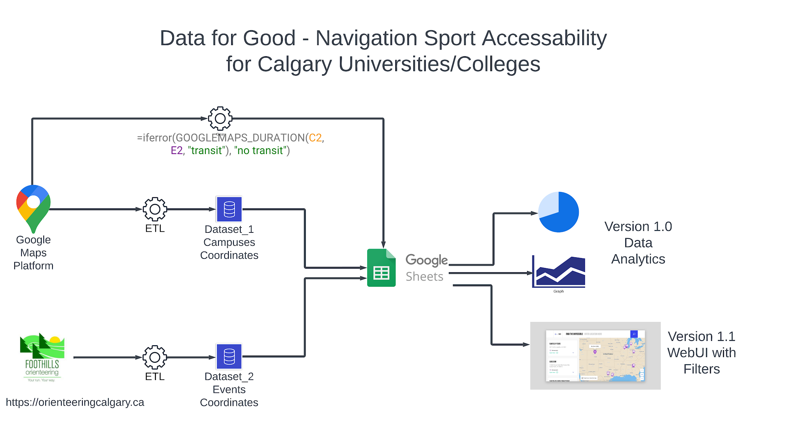

Tech approach Option 2:
Run prompt engineering with RAG on LLM - e.g. ChatGPT, Gemini.
- “Use list of locations as navigation_events from this link https://orienteeringcalgary.ca/maps/report”
- “Use a list of locations as university_locations from querying google maps for ‘Calgary universities and colleges’ “
- “Find what percentage of navigation_events are accessible from university_locations via public transit”

(see wireframes on the next page below)

WebUI wireframes:
